**Project Design Phase-II**

**Technology Stack (Architecture & Stack)**

|  |  |
| --- | --- |
| Date | 14 APRIL 2025 |
| Team ID | SWTID1742640402 |
| Project Name | MyRide |
| Maximum Marks | 4 Marks |

**Technology Stack**

To build a scalable, secure, and high-performance **Cab Booking App**, we carefully selected the following technologies based on project goals, team expertise, and industry standards.

1.**Frontend (React.js)**

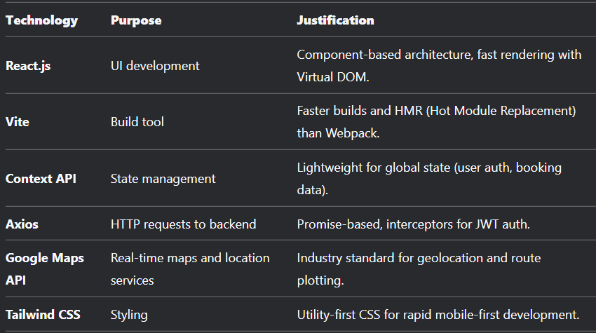

**2.Backend (Node.js + Express.js)**

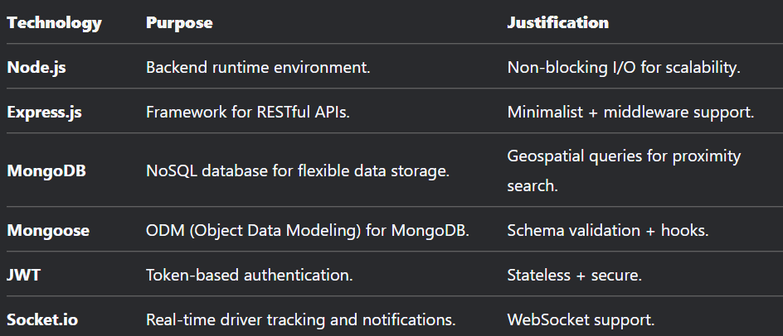

**Why This Stack?**

* **Performance**: React (Virtual DOM) + Node (non-blocking I/O) ensure speed.
* **Scalability**: MongoDB sharding + Redis caching handle growth.
* **Safety**: JWT + HTTPS + rate limiting for secure APIs.
* **Cost-Effective**: Open-source tools reduce licensing costs.